Shabbos Stories For
Parshas shoftim 5786
Volume 17, Issue 49 2 Elul/August 15, 2026
Printed L’illuy nishmas Nechama bas R’ Noach, a”h

No One Loses Out by Being Faithful to Hashem
By Rabbi David Bibi


Rabbi Berel Lazar and Russian President Vladmir Putin

At times, we are convinced that doing the right thing will cost us an opportunity, a promotion, financial success, or recognition. The Torah tells us otherwise. We may not immediately understand HaShem's plan, but we never lose by remaining faithful to it.
Rav Biderman illustrates this principle with two unforgettable stories.
A young Jewish man in Russia spent fourteen years preparing to become a brain surgeon. Russian law required every graduate to appear personally on one designated day to receive his diploma. Missing that day meant forfeiting years of study. Tragically, the ceremony was scheduled for Shavuot.
The young man approached Rabbi Berel Lazar, Chief Rabbi of Russia, hoping some halachic solution might exist. After exploring every possibility, Rabbi Lazar sadly concluded that there was none. The young man would have to choose between violating Yom Tov or surrendering the career for which he had sacrificed fourteen years.
He chose HaShem.
Shavuot came and went. He remained home. The Ministry of Education refused every appeal. It appeared that Torah had cost him everything.
Six months later, during the annual Chanukah celebration at the Kremlin, Rabbi Lazar spoke about the *mesirut nefesh* of the Maccabees and then described this young ba'al teshuvah who had surrendered his entire medical career rather than desecrate the sanctity of Shavuot.
The Vladimir Putin, the President of Russia, deeply moved, asked whether the story was true. Upon learning that it was, he personally instructed the Ministry of Education to issue the diploma and arranged to present it himself. This brought the doctor fame in Russia.
That young man eventually immigrated to Eretz Yisrael, where he became one of the leading neurosurgeons at Shaarei Tzedek Medical Center in Yerushalayim.
He believed he was giving up everything.
In reality, HaShem was preparing something even greater.
Rav Biderman then relates a story about the Pnei Menachem of Gur. After agreeing to purchase an apartment, he learned that the seller had fallen into financial hardship and would not be able to vacate the property on time. Legally, the Pnei Menachem could have insisted on the terms of the contract. Instead, he told the seller to remain as long as necessary and even prepaid the full purchase price months before it was due because the family desperately needed the money.
Shortly afterward, the merchant safeguarding the Pnei Menachem's escrow funds suffered financial collapse. Had he not withdrawn the money early in order to help another Jew, his own savings would have disappeared.
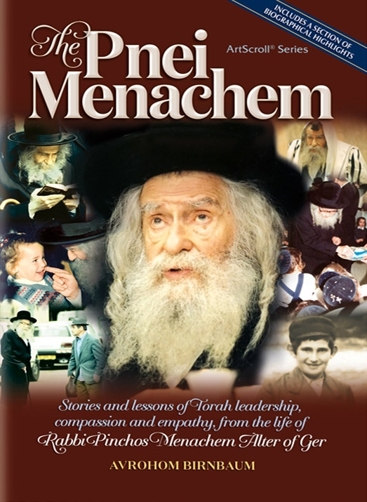

Only afterward did he understand that HaShem had quietly protected him through an act of kindness performed lifnim mi-shurat ha-din, beyond the strict letter of the law.
Both stories teach precisely the same lesson. When we stand before a difficult decision, we naturally ask, "What will happen if we do the right thing?" The Torah encourages us to ask a different question: "What might HaShem already be preparing because we chose to do the right thing?" We rarely know the answer.. The young medical student did not know. The Pnei Menachem did not know. They simply trusted their Father in Heaven.

Reprinted from the Parshat Devorim 5786 email of Shabbat Shalom from Cyberspace.
For You…For Me
By Rabbi Moshe Hirschberg



Sometimes the greatest kindness we can do for another Jew is not only to care for them physically, but to open a siddur, daven for them, and sincerely plead on their behalf. Often, the very brachos we ask Hashem to bestow upon someone else find their way back to us as well.
Mrs. Levenberg was informed that four young men associated with Yad Yisroel were in desperate need of lodging. These boys had grown up in Russia with little, if any, connection to Yiddishkeit. Yad Yisroel had discovered these precious lost neshamos, brought them close to Torah and mitzvos, ignited within them a love for Yiddishkeit, and reconnected them with their heritage.
As they matured, each decided it was time to enter the workforce. They left the supportive environment of Yad Yisroel and began the difficult transition to independent life, needing to earn a parnassah while also finding a place to live. Their plan was to rent a house together, split the expenses, and each work in the profession that suited him best.
While searching for housing, they turned to Mrs. Levenberg. Knowing that she had an unused attic, they hoped she might be willing to host them temporarily. They had spent many Shabbosim, seudos, and nights in the Levenberg home over the years, and she gladly welcomed them in.
Temporary, however, became much longer than anyone had anticipated. Finding a suitable house proved far more difficult than expected, and the boys remained in Mrs. Levenberg’s attic.
At first, she cared for them with boundless enthusiasm. She prepared food, did laundry, and tended to whatever they needed. But as the months passed, the arrangement naturally became more challenging having to share her home with four unwed young men. For example, if her husband was away, she would step out of her home for some time to avoid yichud while the boys were there.
Yet, she kept reminding herself, “I don’t regret this mitzvah. I’m happy to do it, and I want to continue. But I hope they can soon move on and build families of their own.”
For a long time, Mrs. Levenberg had even tried arranging shidduchim for the boys, but nothing seemed to get off the ground.
Then one day, a different thought occurred to her. These four young men had no one to cry for them. No Jewish mother was pouring out her heart on their behalf. She decided that if no one else was davening for them, she would.
From that day forward, she made each of them part of her daily tefillos. She begged Hashem that they should each find their bashert, build faithful Jewish homes, and finally have homes of their own.
Within three months — twelve and a half weeks! — every one of the four boys became engaged.
Who can measure the power of a heartfelt tefillah offered on behalf of another person? We may never know what such prayers accomplish in Shamayim.
But the story doesn’t end there.
At the wedding of one of these young men, the shadchan approached Rabbi Levenberg and asked if he would pay the shadchanus fee. Technically, he had no obligation; the young man was not his son, nor was he his legal guardian. Nevertheless, Rabbi Levenberg called his Rav to ask what he should do.
His Rav answered simply, “Pay the shadchanus. Let it be a zechus for your son.” Rabbi Levenberg did exactly that.
Sometime later, that couple asked if they could spend Pesach with the Levenbergs. Mrs. Levenberg happily agreed. Throughout Yom Tov, the young kallah repeatedly told Mrs. Levenberg that she knew the perfect girl for her son. But since the kallah came from a very different background, Mrs. Levenberg politely dismissed the suggestion each time.
Still, after hearing it again and again, she finally agreed to take down the name and phone number.
Not long afterward, the suggestion developed into a shidduch, which led to an engagement.
The very couple for whom Mrs. Levenberg had davened so fervently became the catalyst for her own son finding his bashert.

Reprinted from the Parshas Devorim 5786 email of Zichru Toras Moshe.
Why Must We Suffer?

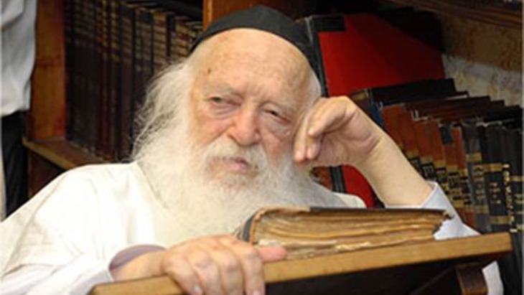

Many people would regularly gather at the home of Rav Chaim Kanievsky, zt”l, in Bnei Brak, to seek his advice and Brachah. Once, a man asked Rav Chaim, “How does the Rav explain the troubles that Klal Yisroel is facing? For many years I have been involved in Chesed activities, and never do I remember a time during which Yidden have been plagued with such troubles. How do we explain this?”
All those present awaited Rav Chaim’s answer. “It is well known,” said Rav Chaim, “that during the generation of Moshiach, HaKadosh Boruch Hu will clean out the generation of its Aveiros and purify us in order to greet Moshiach. How does Hashem clean us of our Aveiros? With Tzaros— troubles and hardships. That is the reason for today's predicament.”
One of the people in the room asked Rav Chaim, “But Rebbe, until when? How much more must we endure?”
Rav Chaim closed his eyes and told those assembled, “Believe me, we are already near the end. We are really near the end…”
Reprinted from the Parshas Devorim 5786 email of Rabbi Yehuda Winzelberg’s Torah U’Tefillah.
An Honorable Position
By Avrohom Barash

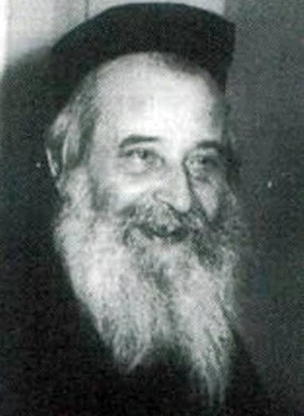

R’ Yechezkel Sarna was the Rosh Yeshivah of the Hebron Yeshivah before and after World War II. One of the members of the kollel for married scholars was a great talmid hacham and a genius of note, but he did not succeed in any business ventures and was destitute. Someone suggested to the Rosh Yeshivah that perhaps this scholar should take the job of reciting Kaddish for those people who, knowing they would leave no survivors, had given money to the yeshivah to hire someone to undertake this task.
R’ Yechezkel replied that he did not agree; while it was surely a great merit for these deceased individuals, the recitation of Kaddish for them was usually performed by the shammash, and the scholar might feel slighted at being given such a job.
Then R’ Yechezkel promptly informed the secretary that he himself would be reciting Kaddish for those who had paid for the service! The man did not have the temerity to ask the Rosh Yeshivah why it was appropriate for him to undertake the job, but he did wonder about it.
The mystery was solved some four weeks later when R’ Yechezkel approached the secretary and asked him to request that the impoverished scholar relieve him of the duty, instructing him to tell the man, “The Rosh Yeshivah has been saying Kaddish, but does not have the strength for it, and would like to offer the job to you.” Once R’ Yechezkel himself had been doing it, there was no shame in the other man performing the same task.

Excerpted from the ArtScroll book – “Gut Voch” by Avrohom Barash.
It Didn’t Come Down!
By Rabbi Yechiel Spero

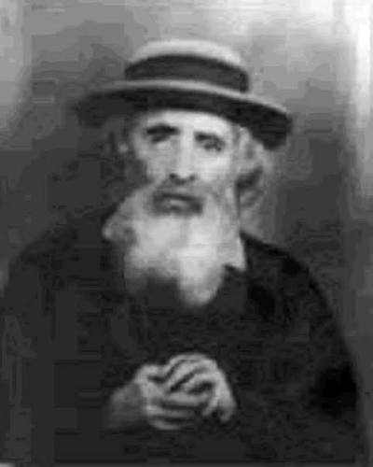

The young man appointed to walk Rav Yehoshua Leib Diskin, the Rav of Yerushalayim, to shul waited patiently outside the Rav’s home. After a few moments, the door opened and the Rav emerged, carrying his talet and tefillin. But instead of heading down the street toward the shul, he began to climb the stairs outside his home, one step at a time until he reached the top. The Rav was already an elderly man; it would take much effort for him just to walk to shul. Why, then, was he climbing the stairs outside his home?
The scenario grew even stranger, for when Rav Yehoshua Leib reached the top of the steps, he seemed to be looking for something. No longer able to control his curiosity, the young man waited for the venerated Sage to come back down and then asked him what he was looking for.
Rav Yehoshua Leib looked directly into the young man’s eyes. “You know, the first two Batei Mikdash (Temples), which were man made, were built during the day. But the third one will descend in a heavenly blaze - and that can happen even at night. I was just looking to see if it came down last night.” And then the Rav added plaintively, “It didn’t.”
The stunned talmid did not move. He just stared in disbelief at his disappointed Rebbe who was already on his way to shul. He still had much for which to pray. May it be rebuilt speedily in our days, Amen. (Touched by a Story 3)
Excerpted from the ArtScroll book – “Touched By a Story 3” by Rabbi Yechiel Spero.
The Chief Rabbi’s Amazing Promise!
By Yoni Schwartz

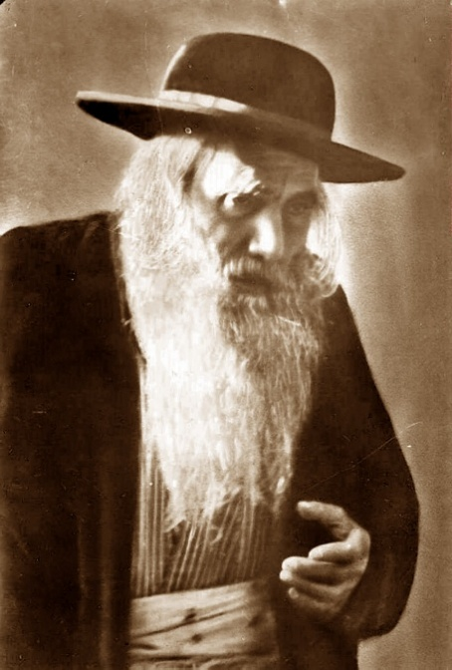

Some years ago, in Yerushalayim, a couple celebrated their fiftieth wedding anniversary. This couple was unique in that they seemed to have been blessed with it all: a good livelihood, good health, children, and grandchildren who all stayed on the derech, etc. At the family gathering, one of the grandkids asked his grandfather how this happened.
He responded with the following story. Back in my day, Rav Yosef Chaim Sonnenfeld, ZT”L, was the Chief Rabbi of Jerusalem and was the mesader kiddushin (the officiating rabbi) at the wedding of an older girl who struggled for many years to find her match. When the boy's family was preparing the kesubah (marriage contract), the boy started getting cold feet and, a few minutes later, ran off. Nobody could find him. The place was buzzing. The kallah’s father was very anxious because he knew how this would destroy his daughter. The boy’s father was a mess because this was the last thing he expected. Amidst all this, the kallah didn’t yet know; she was in another room.
Suddenly, the doors opened. Rav Yosef Chaim Sonnenfeld walked into the room. Everybody flocked to him for guidance. Having to think fast, the Rav turned to the boy’s friends and asked, “Who wants a guaranteed share in Olam Haba (Heaven) and Olam Hazeh (this world)? All you must do is marry the kallah.”
All the boys were silent, so he started picking them one by one. One boy responded, “I can’t - my mother would kill me.” Other boys declined, as well. Finally, one boy responded, “Do you really promise those things?”
Rav Sonnenfeld responded, “Yes.”
The boy said, “OK, I’ll do it.”
Rav Sonnenfeld went over to the kallah’s father and said, “I found a chosson - a nice new boy for your daughter. He’ll marry her tonight.”
The father replied, “But my daughter doesn’t even know what’s going on.”
Rav Sonnenfeld replied, “Nu… so let’s introduce them.”
The grandfather told his grandson, “I was that boy. We met, we married, and fifty years later, we could both attest that it was the best decision of our lives.”

Reprinted from the Parshas Matos-Ma’asei 5786 email of Torah Sweets.

The Baal Shem Tov
and the Arrogant Host
By Yehuda Z Klitnick

In the time of the heilige Baal Shem Tov, there was a Jewish man who was a great practitioner of Hachnasas Orchim (hospitality). He kept an open house for all, providing every guest with food, drink, and lodging for the night, and he would furthermore give them a charitable gift of cash.
The Baal Shem Tov became aware of the greatness of this man’s deeds. However, the Baal Shem Tov also noticed that there was a flaw in his actions, as the mitzvah was not attaining satisfaction in Heaven.
This bothered the Baal Shem Tov greatly, and he wanted to know what the Yid was doing wrong. After looking into it, he discovered that the Yid possessed one major flaw: he would boast to every guest he accepted into his house, saying, "Indeed, am I not a truly grand host?!"
The man's pride was causing his spiritual merits to be transferred to the Sitra Achra (the side of impurity). [In Kabbalah we learn that Hashem divides everything in this world into either Sitra D’Kedushah (the side of holiness) or Sitra Achra (the side of impurity)—literally meaning “the other side,” or the side of Kelipah. There is nothing in between; every thought, word, action, or creation has its source either in Kedushah or Kelipah.]
The tragedy was that the Yid believed he was building a massive treasury of rewards for the World to Come, while in reality, his pride and arrogance were completely draining his spiritual rewards. The Baal Shem Tov, who had a great love for every fellow Yid, felt pity for him. He decided he must do something to rectify the man's trait and set him on the straight path, especially since he was performing such tremendous good deeds.
Therefore, the Baal Shem Tov dispatched one of his closest talmidim (disciples), Rav Volf Kitzes, to visit the man as a guest. The Yid realized that this guest was a tzaddik and received Rav Volf beautifully, serving him food and drink. Then, as was his custom, he began to boast:
"Indeed, am I not a grand host?!"
Rav Volf simply replied to him, "Well, we shall see."
An hour later, the Yid boasted again, and Rav Volf replied once more, "Well, we shall see."
The Yid asked if he could sleep in the same room. Rav Volf agreed. When it was time to sleep, the host, finally exhausted from the day's great commotion, drifted off. Rav Volf then approached him and gently took hold of his pinky finger.
The man immediately began to dream: He dreamed that the king had arrived at his home, and he honored the king by serving him tea. Suddenly, while drinking, the king fainted and died. A false accusation was leveled against the man, alleging that he had served poisoned tea, and he was thrown into a harsh dungeon. By a miracle, the prison caught fire, allowing him to escape.
He fled to a distant city, and having no way to sustain himself, he was forced
to become a water-carrier. However, water-carrying in that city paid so poorly that he could not earn a livelihood. So, he traveled to another city where the pay was higher. But in this new city, the rules were incredibly strict: if a carrier brought a bucket that wasn't completely full, the water was confiscated without payment. Therefore, he had to be exceedingly careful while carrying his load.
One day, however, he tripped while carrying the water and broke his nose. Lying there injured and sick, he began to reflect on how he had once been a wealthy man, but had now fallen to such a low state in a foreign land—and he began to weep bitterly (all of this taking place within the dream).
At that moment, Rav Volf let go of his finger. The man startled awake and realized that he was actually lying honorably in his own bed among his guests. Out of sheer joy and relief, he nearly fainted. Rav Volf revived him and said, "All of this befell you because you constantly boast and are arrogant about your mitzvah. Therefore, you must travel to the Baal Shem Tov to seek a path of repentance."
And so, it was. The man traveled to the Baal Shem Tov. The Baal Shem Tov showed him spiritually how the entire merit of his hospitality was being redirected to the Sitra Achra. The man was shocked to hear this and lowered his face in shame, declaring that he was ready to rectify his actions. The Baal Shem Tov told him exactly what he needed to do and undertake in order to straighten his path.
The Yid accepted everything the Baal Shem Tov prescribed, taking upon himself a penance to atone for his wrongdoings. He fulfilled it completely, and from that day forward, he ceased boasting about his good deeds.
A while later, the Baal Shem Tov was speaking with Rav Volf, and the progress of the Yid came up. The Baal Shem Tov shared the good news with Rav Volf: the Yid’s hospitality was now shining brightly in Heaven!

Reprinted from the Parshas Devorim 5786 email of Pardes Yehuda.

The Wrong Travel Directions

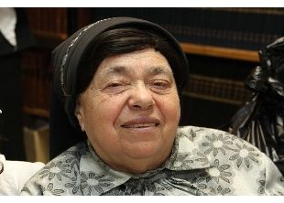
Rebbetzin Batsheva Kanievsky a”h

The following story was related by the celebrated maggid, R’ Chizkiyahu Yosef Karlenstein shlita: A young secular woman by the name of Shiran lived in Beer Sheva. Her life had become a relentless march of heartbreak and misfortune. Weary, emotionally drained, and sinking into deep despair, she finally unburdened her heart to her colleague Noa.

A Piece of Advice that Sounded Completely Absurd
To Shiran’s absolute astonishment, Noa responded not with conventional sympathy, but with a piece of advice that sounded completely absurd: she suggested a journey to Bnei Brak to visit an elderly Rabbanit named Rebbetzin Batsheva Kanievsky a”h, a renowned figure in the Orthodox world, rumored to work wonders.
Shiran was appalled at the thought of venturing into an ultra-Orthodox enclave where she felt alienated and expected hostility and judgment. Yet Noa remained steadfast, sharing her own past struggles and explaining how a single, desperate visit to the compassionate Rebbetzin had helped her find the strength to rebuild her life. Seeing Shiran’s deep skepticism and fear of being ostracized, Noa generously offered to accompany her, promising to guide her through the unfamiliar territory and dress respectfully alongside her for the brief trip.

Directed to Take the 54 Bus
The next afternoon, the two friends set off toward Bnei Brak. Alighting near Rechov Rabbi Akiva, they asked a friendly passerby for directions to Rechov Rashbam. Directed to take the 54 bus, they waited at the stop for fifty long, frustrating minutes until a cluster of buses finally arrived. Boarding one, they took their seats in the back row, right behind a fourteen-year-old yeshivah bochur who was deeply absorbed in a sefer.
Seeking reassurance, Noa politely leaned forward and asked if he knew where they should get off for Rechov Rashbam. The teenager, startled and visibly distracted, quickly informed them that their destination was the very next stop. Following his advice, they disembarked, only to look at the bus shelter and realize that they had been dropped off far too early and were still roughly ten stops away. Shiran flew into a tailspin of fury. Convinced that the boy had intentionally misled them out of malice and prejudice against non-observant women, she vented her rage bitterly while Noa quietly tried to soothe her and keep her focused on their purpose.

Gasped in Disbelief and Anger
Eventually, a second bus arrived, bringing an end to Shiran’s tirade and delivering them to Rechov Nechemia. Noa navigated from memory until they reached the Rebbetzin’s building on Rashbam. But just as they approached the entrance, Shiran gasped in disbelief and anger. Standing right there in the stairwell was the very same fourteen-year-old boy who had given them the wrong directions. Seething with indignation, the two women marched inside, expecting a confrontation.
However, before they could unleash their frustration, the boy retreated slightly and asked if they were the women who had questioned him on the bus earlier. When they confirmed their identity, he immediately offered a sincere and humble apology. He explained that after they had gotten off, he realized with horror that he had given them incorrect information. Rather than continuing on to his original destination, he had immediately disembarked, taken a bus to Rechov Rashbam assuming they were headed to Rebbetzin Kanievsky, and waited in the stairwell for half an hour hoping to intercept them.

Stunned into Absolute Silence
Reaching into his pocket, he handed them the exact bus fare to compensate for their wasted ticket before quietly slipping away. Stunned into absolute silence by this extraordinary display of integrity, Shiran and Noa stood frozen for a moment before proceeding upstairs to the Rebbetzin’s apartment.
When they were ushered inside, the holy woman received them with immense warmth, her eyes overflowing with genuine love and empathy. Shiran unburdened her heart, receiving priceless counsel and a heartfelt blessing, followed by Noa, who also requested a blessing.

The Rebbetzin’s Explanation
Before leaving, Shiran could not help but recount the surreal encounter in the stairwell, asking the Rebbetzin if she could explain such unheard-of behavior from a stranger. Rebbetzin Kanievsky smiled gently and explained that there was nothing strange about it at all. A youth raised on the principles of Torah and refined character is taught to live with absolute honesty, making it second nature to take responsibility for a mistake and make amends beyond what the strict law requires.
Turning to Shiran, Noa expressed a profound revelation: a community like this that lived in a world built on truth and integrity was where she wanted to build her own future family.

Reprinted from the Parshas Va’eschanan 5786 email of Rabbi Dovid Hoffman’s Torah Tavlin.

